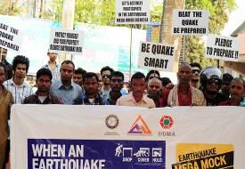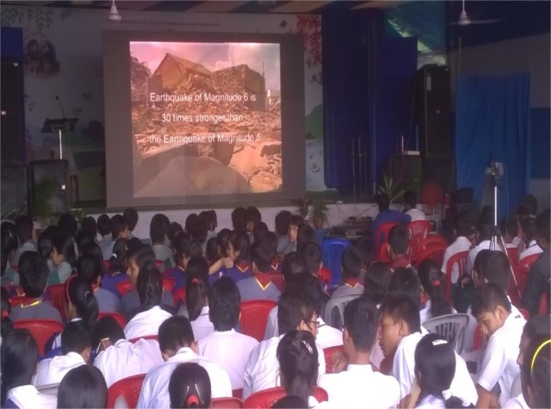**Impact Assessment of M8.7 Shillong 1897 Earthquake Scenario: NE Multi State Preparedness Campaign Project**

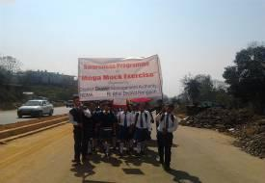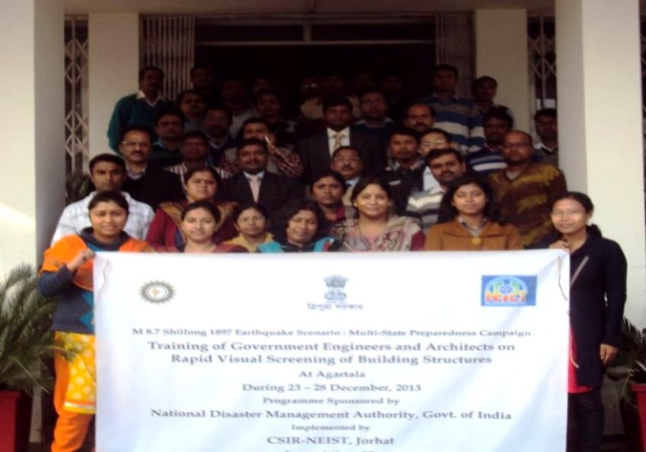

**FINAL REPORT**

**2016**

**Indian Institute of Public Administration**

**New Delhi**



|  |  |  |
| --- | --- | --- |
| **REPORT** | | |
|  |  |  |
| **Project**  **Title:** | Impact Assessment of M.8.7 Shillong 1897 Earthquake Scenario: NE Multi State Preparedness Campaign Project |  |
| **Country :** | India |  |
| **Sponsoring Agency:** | National Disaster Management Authority | National Disaster Management Authority  NDMA Bhawan  A-1 Safdarjung Enclave  New Delhi-110029 |
| **Evaluator:** | Indian Institute of Public Administration | I.P Estate  Ring Road  New Delhi 110 002 |
| **Date of report:** | May 2016 |  |
| **Period:** | March- May 2016 |  |
|  |  |  |
| **Project Investigator(s)** | Prof. Vinod K Sharma  Dr. Shyamli Singh | Research Officer:  Dr. Lolita Pradhan |

|  |
| --- |
|  |
| Impact Assessment of M 8.7 Shillong 1897 Earthquake Scenario: NE Multi State Preparedness Campaign Project |
|  |
|  |

**Indian Institute of Public Administration, New Delhi**